COMPLETE THIS 2026 VOLUNTEER INFORMATION FORM
and SEND THIS PAGE TO COMMUNITY PROJECTS FOR SENIORS.

3 Ways to Send  This Page to  Community Projects for Seniors | MAIL | EMAIL | FAX
3 Ways to Send  This Page to  Community Projects for Seniors | Community Projects for Seniors  3073 S Chase Ave, Building 1, Suite 210  Milwaukee WI 53207 | CPforSeniors@gmail.com | 414-444-6237

We need nearly 400 volunteers to help us prepare, package & deliver
more than 3,000 free hot meals on each major holiday:

Thanksgiving Day (11-26-26), Christmas Day (12-25-26), & Easter Sunday (3-28-2027).
  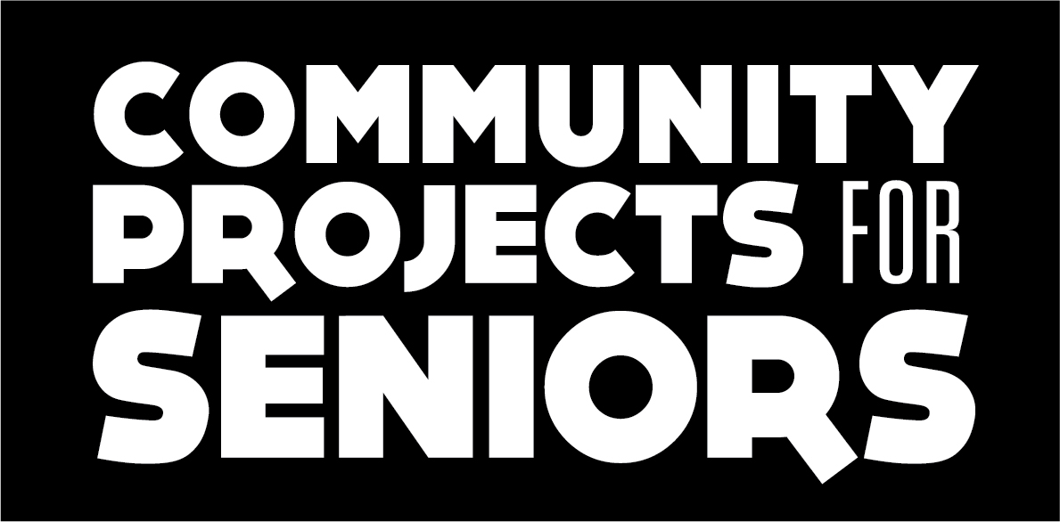 |   

VOLUNTEER  ORIENTATIONS | Each session takes approx. 55 minutes, and covers facts about our organization,  upcoming program & fundraising events, volunteer opportunities,  and policy/procedure updates for current volunteers.

First name
Last name
Mailing address
City-State-Zip
Primary preferred Phone # | Today’s Date:
Primary preferred Email
Community service hours | Put an X here if it applies to you: I am inquiring because I have court-ordered community service hours.  Put an X here if it applies to you: I am inquiring because I need community service volunteer hours for school.

Dates & Times of 2026 Volunteer Orientations.
Select (put an X) by the session you can attend.


 | Thursday, October 29, 2026 | 4:00 P.M.
 | Saturday, November 7, 2026 | 10:00 A.M. | Final orientation before Thanksgiving
 | Saturday, December 5, 2026 | 10:00 A.M. | Final orientation before Christmas

Volunteer Orientations are at our office at 3073 S. Chase Ave, Building #1, Suite #210, Milwaukee WI 53207.

DIRECTIONS. Intersection of Chase Ave & Oklahoma Ave. ENTRANCE DRIVEWAY is on Oklahoma Ave (not Chase Ave!).

You can enter the building at the “FRONT” DOOR where you see glass doors to the RIGHT of the great big #1. Come to the 2nd floor. Call Jeffery at 414-708-2413 if you get lost. If all of the spots are filled in the “front” - go to the back (north of the building) and park in the huge parking lot, then walk back up to the “front” door. Follow our paper signs with arrows, once inside the building.

Community Projects Committee, Inc. | Community Projects for Seniors | 414-444-6544 | CPforSeniors@gmail.com | CPforSeniors.org
3073 S Chase Ave, Building 1, Suite 210 Milwaukee WI 53207
Exec Director, Jeffery Hansen: 414-708-2413 (mobile) cpsJeffery@gmail.com

